**Abstract**

The RFID-based Attendance System stands at the forefront of innovation, heralding a transformative era in attendance tracking across educational and organizational landscapes. Propelled by cutting-edge Radio-Frequency Identification (RFID) technology, the system seamlessly integrates hardware components, including the NodeMCU microcontroller and the MFRC522 RFID module, during the meticulous system design phase. As the hardware setup unfolds, meticulous connectivity ensures the harmonious interplay between the RFID module and the NodeMCU. In parallel, the software development journey is embarked upon, where the Arduino IDE becomes the crucible for crafting firmware that not only initializes the RFID module but also orchestrates intricate Wi-Fi connectivity and communication with the server. On the server side, a robust infrastructure takes shape, adept at managing HTTP requests and housing a purpose-built database tasked with storing and updating RFID card information and attendance records. Rigorous testing stages, encompassing individual component assessments and simulated RFID card events, attest to the system's real-world responsiveness and reliability. The deployment phase transposes the system from the crucible of testing to the actual educational or organizational settings, emphasizing prolonged stability through vigilant monitoring and maintenance mechanisms. Comprehensive documentation acts as the archival backbone, encapsulating the intricate nuances of system architecture, hardware connections, and software code. User manuals burgeon, providing administrators and end-users alike with an indispensable guide. As the system looks ahead, its future trajectory unfolds with the promise of biometric integration, advanced data analytics, mobile app development, and global scalability considerations. In harmonizing technology with administrative efficacy, the RFID-based Attendance System not only assuages immediate needs but asserts itself as an adaptive and prescient solution poised to navigate the dynamic landscape of attendance management.

Table of Contents

**1. Introduction and Theoretical Background** vi

**2. Project Design** vii

**2.1 Component List** vii

**2.2 Circuit Diagram** vii

**2.3 Methodology** viii

**2.4 Code** ix

**3. Expected Result** xii

**4. Conclusion** xiii

**5.1 Future Scope** xiv

Table 2.1: Component List vii

Table 2.2: Component Connection viii

Figure 2.1: Circuit Diagram vii

# **1. Introduction and Theoretical Background**

The RFID-based Attendance System is a modern solution designed to streamline and automate the attendance tracking process in various settings such as classrooms, offices, or any environment requiring accurate attendance records. Leveraging Radio-Frequency Identification (RFID) technology, this system offers a robust and efficient method for identifying individuals and recording their attendance seamlessly.

This project is driven by the need for a reliable and automated attendance management system that eliminates manual data entry, reduces errors, and enhances the overall efficiency of attendance tracking. The utilization of RFID technology ensures quick and non-intrusive identification, making it an ideal solution for large groups of individuals.

The methodology encompasses several key phases, starting with the definition of system requirements and the selection of appropriate hardware components, including the NodeMCU (ESP8266) microcontroller and the MFRC522 RFID module. The system's architecture is carefully designed to facilitate the flow of data between the RFID module, NodeMCU, and a server, ensuring a seamless and secure communication process.

Hardware setup involves connecting the RFID module and an LED indicator to the NodeMCU, adhering to specified hardware specifications and pin configurations. Adequate power supply considerations are addressed to ensure the stable operation of all components.

The software development phase entails writing firmware for the NodeMCU using the Arduino IDE. Functions are implemented to initialize the RFID module, establish a Wi-Fi connection, and manage communication with the server. Additional functionalities include reading RFID card information and transmitting it to the server, along with error-handling mechanisms to ensure stable operation.

On the server side, a dedicated system is set up to handle HTTP requests from the NodeMCU. A database is created to store RFID card information and attendance records. Server-side scripts, developed using PHP or other server-side languages, process incoming data, update the database, and respond to the NodeMCU with relevant information.

Testing is conducted at both the individual component level and through integration to verify proper functionality. Simulated RFID card events are used to assess the system's response, ensuring accuracy and reliability in real-world scenarios.

Upon successful testing, the system is deployed in the target environment, be it a classroom or office. Stability and reliability are continuously monitored, with implemented mechanisms for addressing any issues that may arise during operation. A comprehensive documentation process covers system architecture, hardware connections, software code, and user manuals to provide a reference for future maintenance and improvements.

# **2. Project Design**

## **2.1 Component List**

|  |  |  |
| --- | --- | --- |
| **Component Name** | **No of Components** | **Purpose** |
| NodeMCU (ESP8266) | 01 | Brain of this project |
| MFRC522 RFID module | 01 | It will read the RFID card |
| 5v Relay | 01 | It will convert 5v power to 12v power |
| Solenoid | 01 | The door lock |
| LED | 02 | Indicating Locked door |
| Display (GLCD & OLED) | 02 | For displaying |
| Wires | Few | To connect the components |

Table 2.: Component List

## **2.2 Circuit Diagram**

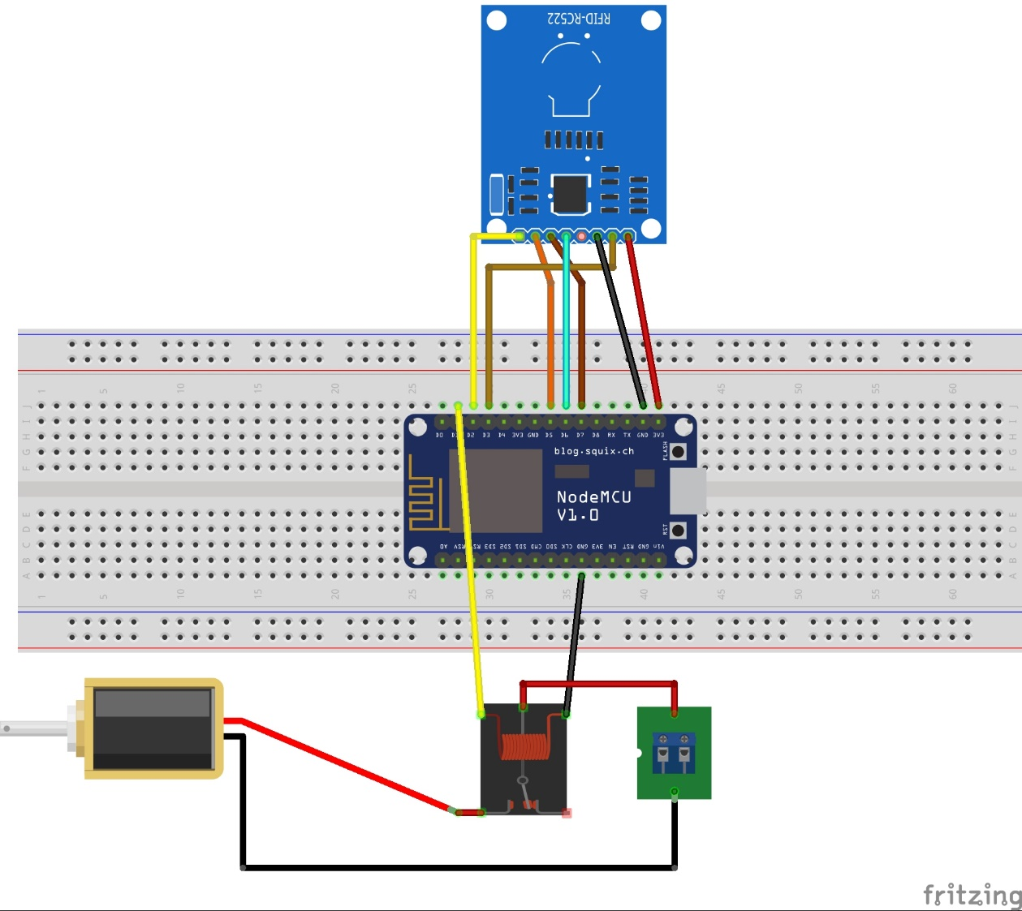

Figure 2.: Circuit Diagram

|  |  |
| --- | --- |
| **NodeMCU** | **MFRC522 RFID module** |
| D2 | SDA/SS |
| D3 | RST |
| D5 | SCK |
| D6 | MISO |
| D7 | MOSI |
|  | |
| NodeMCU | Other |
| D1 | Relay CO |

Table 2.: Component Connection

## **2.3 Methodology**

The methodology for implementing the RFID-based Attendance System involves several steps. Below is a high-level outline of the key phases and activities:

1. **System Design:**
   * Define the system requirements, including the need for RFID card identification and attendance tracking.
   * Choose appropriate hardware components, such as the NodeMCU (ESP8266) microcontroller and the MFRC522 RFID module.
   * Design the overall architecture of the system, considering the flow of data between the RFID module, NodeMCU, and the server.
2. **Hardware Setup:**
   * Connect the RFID module (MFRC522) and LED to the NodeMCU, following the hardware specifications and pin configurations.
   * Ensure proper power supply for all components.
3. **Software Development:**
   * Write the firmware for the NodeMCU using the Arduino IDE.
   * Implement functions to initialize the RFID module, establish a Wi-Fi connection, and handle communication with the server.
   * Write functions to read RFID card information and send it to the server.
   * Develop error-handling mechanisms and implement necessary delays to ensure stable operation.
4. **Server-Side Development:**
   * Set up a server to handle HTTP requests from the NodeMCU.
   * Create a database to store RFID card information and attendance records.
   * Develop server-side scripts (PHP or other server-side language) to process incoming data, update the database, and respond to the NodeMCU with relevant information.
5. **Testing:**
   * Test the individual components, such as the RFID module, NodeMCU, and LED, to ensure they function as expected.
   * Perform integration testing to verify the communication between the NodeMCU and the server.
   * Simulate RFID card events and check the system's response.
6. **Deployment:**
   * Deploy the complete system in the target environment (e.g., a classroom or office).
   * Ensure stable and reliable operation over an extended period.
7. **Monitoring and Maintenance:**
   * Implement monitoring mechanisms to identify and address any issues that may arise during system operation.
   * Provide a maintenance plan for addressing hardware failures, software updates, or changes in system requirements.
8. **Documentation:**
   * Document the system architecture, hardware connections, and software code for future reference.
   * Create user manuals and guides for administrators and end-users.

By following these steps, you can systematically develop, test, and deploy the RFID-based Attendance System, ensuring its functionality and reliability in real-world

## **2.4 Code**

|  |
| --- |
| // Libraries  Include SPI library  Include MFRC522 library  Include ESP8266WiFi library  Include ESP8266HTTPClient library    // WiFi Client  Create WiFiClient object wifiClient    // Define RFID pins  Define SS_PIN as D2  Define RST_PIN as D3  Define led as D1    // Create MFRC522 instance  Create MFRC522 instance mfrc522 with SS_PIN and RST_PIN    // WiFi credentials  Set ssid as "SSID_Name"  Set password as "Password"  Set device_token as "Token"    // Server URL  Set URL as "Server Name"    // Variables  String getData, Link  String OldCardID = ""  unsigned long previousMillis = 0    // Connect to WiFi function  Function connectToWiFi():  Set WiFi mode to WIFI_OFF  Delay for 1000 milliseconds  Set WiFi mode to WIFI_STA  Print "Connecting to ssid"  Begin WiFi connection with ssid and password    While WiFi status is not WL_CONNECTED:  Delay for 500 milliseconds  Print "."    Print newline  Print "Connected"  Print "IP address: "  Print WiFi local IP address  Delay for 1000 milliseconds    // Setup function  Function setup():  Delay for 1000 milliseconds  Begin serial communication with baud rate 115200  Initialize SPI bus  Initialize MFRC522 card  Connect to WiFi  Set led pin mode to OUTPUT    // Loop function  Function loop():  If WiFi is not connected:  Call connectToWiFi function    If current time minus previousMillis is greater than or equal to 15000:  Set previousMillis to current time  Reset OldCardID to an empty string    Delay for 50 milliseconds    If a new card is not present:  Return to the start of the loop    If reading card serial fails:  Return to the start of the loop    Create CardID as an empty string    For each byte in mfrc522.uid:  Append byte to CardID    If CardID is equal to OldCardID:  Return to the start of the loop  Else:  Set OldCardID to CardID    Call SendCardID function with CardID as argument  Delay for 1000 milliseconds    // SendCardID function  Function SendCardID(Card_uid):  Print "Sending the Card ID"    If WiFi is connected:  Create HTTPClient object http    // GET Data  Set getData as "?card_uid=" + Card_uid + "&device_token=" + device_token    // GET method  Set Link as URL + getData  Begin HTTP request with wifiClient and Link    Get HTTP response code  Get response payload    Print HTTP response code  Print Card ID  Print payload    If HTTP response code is 200:  If payload starts with "login":  Set user_name as substring of payload from index 5  Set led pin to HIGH  Else if payload starts with "logout":  Set user_name as substring of payload from index 6  Set led pin to HIGH  Else if payload is "successful" or "available":  // Handle successful or available responses    Delay for 5000 milliseconds  Set led pin to LOW  End HTTP connection |

# **3. Expected Result**

The RFID-based Attendance System aims to deliver a range of tangible benefits and outcomes, contributing to the efficiency and accuracy of attendance tracking in diverse environments. The expected results of this project include:

1. **Automated Attendance Tracking:**
   * Successful and automatic identification of individuals through RFID cards.
   * Elimination of manual attendance recording, reducing human errors and time-consuming processes.
2. **Real-time Data Transmission:**
   * Seamless communication between the NodeMCU and the server, ensuring real-time transmission of attendance data.
   * Swift updates to the server database with accurate attendance records.
3. **User-Friendly Operation:**
   * Intuitive and user-friendly system operation, requiring minimal effort from administrators and end-users.
   * LED indicators providing clear feedback on successful RFID card identification and attendance recording.
4. **Reliable and Stable Operation:**
   * Stable system performance over an extended period, ensuring continuous and reliable attendance tracking.
   * Robust error-handling mechanisms preventing disruptions in operation.
5. **Centralized Attendance Database:**
   * Establishment of a centralized database containing RFID card information and attendance records.
   * Easy retrieval of historical attendance data for reporting and analysis.
6. **Scalability and Adaptability:**
   * Scalability to accommodate varying group sizes and settings, from classrooms to large office environments.
   * Adaptability to changes in RFID card issuance or system requirements.
7. **Accurate Reporting:**
   * Generation of accurate attendance reports based on the stored data.
   * Availability of insights into attendance patterns and trends over time.
8. **Reduction in Administrative Burden:**
   * Reduction of administrative workload associated with manual attendance taking.
   * More efficient use of resources, allowing administrators to focus on other essential tasks.
9. **Improved Accountability:**
   * Increased accountability through a transparent and traceable attendance tracking system.
   * Identification of patterns or irregularities in attendance for further investigation if necessary.
10. **Enhanced Security:**
    * Improved security through the use of RFID technology, minimizing the risk of unauthorized attendance recording.
    * Secure communication protocols between the NodeMCU and the server.

In summary, the expected results of the RFID-based Attendance System encompass increased efficiency, accuracy, and accountability in attendance tracking, ultimately contributing to a more streamlined and effective management process in educational and organizational settings.

# **4. Conclusion**

In conclusion, the RFID-based Attendance System stands as a transformative solution that addresses critical challenges in attendance tracking within educational and organizational settings. Its successful implementation not only fulfills the primary objective of automating attendance management but also significantly streamlines processes, reducing the manual workload associated with traditional attendance recording. The robust communication infrastructure between the NodeMCU and the server ensures the seamless transmission of attendance data in real-time, contributing to the establishment of a centralized database with accurate and up-to-date records. This centralized repository not only enhances record-keeping efficiency but also facilitates data analysis, providing valuable insights into attendance patterns and trends over time.

Furthermore, the system's user-friendly design, marked by clear LED indicators for RFID card identification, fosters accessibility for administrators and end-users. The project's stability and reliability are evident through rigorous testing, showcasing its ability to maintain consistent performance over extended periods. Its scalability and adaptability make it a versatile solution suitable for diverse environments, accommodating varying group sizes and operational requirements. Beyond the immediate benefits of automation and enhanced security, the RFID-based Attendance System lays the foundation for future advancements, demonstrating the transformative potential of RFID technology in optimizing attendance management processes and fostering data-driven decision-making.

# **5.1 Future Scope**

The future outcome of the RFID-based Attendance System holds the potential for several advancements and enhancements, contributing to an even more sophisticated and effective attendance management solution. Anticipated future outcomes include:

1. **Biometric Integration:**
   * Explore incorporating biometric authentication (e.g., fingerprint or facial recognition) for heightened security and accurate identification.
2. **Advanced Data Analytics:**
   * Focus on enhancing data analytics capabilities for predictive analysis and trend identification in attendance records.
3. **Mobile App Development:**
   * Develop a dedicated mobile application for real-time attendance tracking and user notifications.
4. **Machine Learning for Anomaly Detection:**
   * Implement machine learning algorithms to detect and flag anomalous attendance patterns for proactive intervention.
5. **Cloud-Based Architecture:**
   * Transition to a cloud-based architecture for improved scalability, remote management, and seamless data synchronization.
6. **Enhanced User Experience Features:**
   * Continuously improve the user interface with features like self-service portals, personalized dashboards, and interactive data visualizations.
7. **Integration with IoT Devices:**
   * Explore the integration of IoT devices, such as smart sensors, to automate the detection of individuals entering or leaving a space.
8. **Cross-Platform Compatibility:**
   * Prioritize cross-platform compatibility to ensure seamless integration with various hardware and software environments.

These future outcomes aim to enhance the RFID-based Attendance System by incorporating advanced technologies, improving user experience, and preparing the system for the evolving demands of educational and organizational environments.